Chapter 10, Problem 90.

Fig. 10.132 shows a Wien-bridge network. Show that the frequency at which the phase shift between the input and the output signals is zero is f = 0.5πRC, and that the necessary gain is A_{v} = V_{o}/V_{i} = 3 at that frequency.
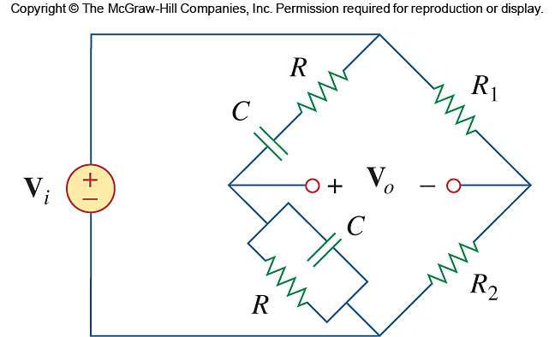

Figure 10.132
For Prob. 10.90.

